LO discuss what makes an item sacred. Lesson 1: The Bible
I can… | Self | Parent
define what scared means
share what I already know about the bible
ask and answer questions to determine whether and item or text, is sacred or not.

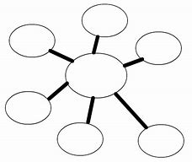
Task 1: Introduce your child to the term sacred. Talk together and brainstorm some ideas here…

Task 2: what are other synonyms that you could use instead of the word sacred? Check that your child understands what a synonym is =A synonym is a word that means the same, or very nearly the same, as another word in the same language. Example = the lady bird is small, the ant is tiny, the bee is little…
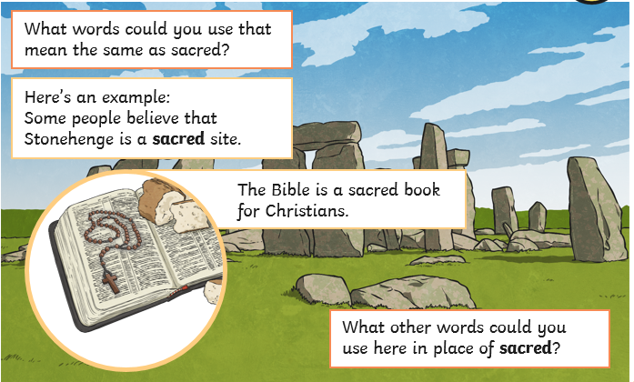
Make your list here:
1) holy
2)
3)
4)
5)
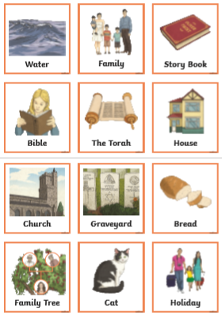
Task 3: Has your child’s idea of sacred changed? Now decide if the items below are sacred or not (put a for sacred, or for not sacred) Then have them write their own definition.
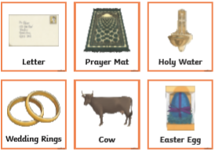
My definition of sacred is: ___________________
_______________________________________
_______________________________________

WALT identify and compare different books of the Bible and their authors. Lesson 2: The Bible
I can… | Self | Parent
explain the difference between the Old and New Testament
understand what the phrase ‘inspired by God’ means
name at least three different authors in the Bible
Task 1: Verbally ask your child the following questions, they can answer true or false, and note their answers, then go through telling them the correct answers.
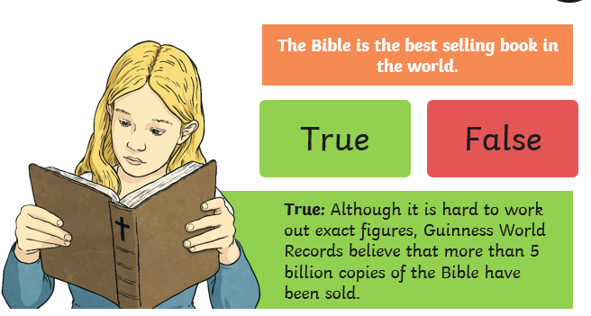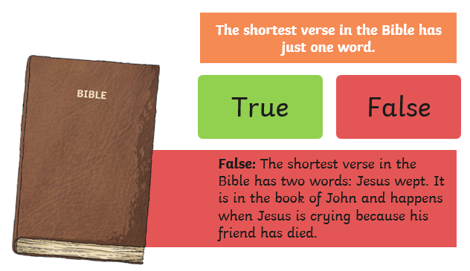
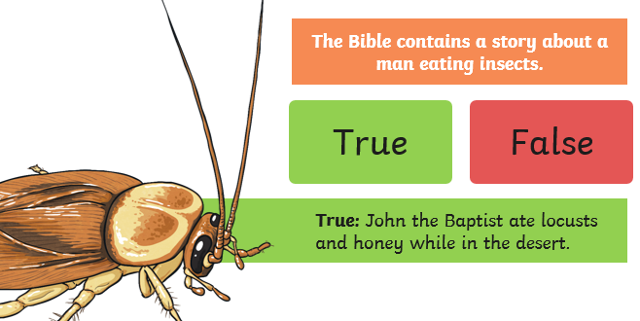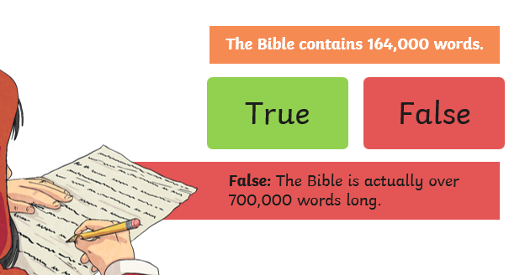
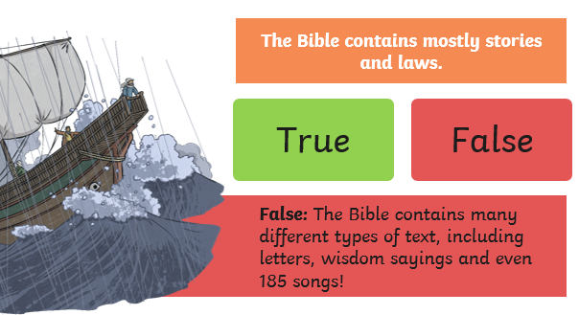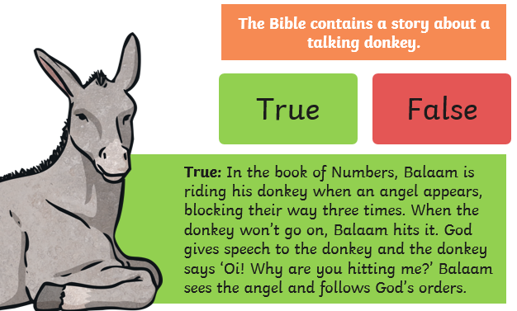
Task 2: Who Wrote the Bible? Using the help below, introduce ‘revelation’ to the children and discuss the Christian belief that God reveals himself to people. Discuss how this relates to the Christian belief that the Bible – or scripture – is God-breathed, or inspired by God.
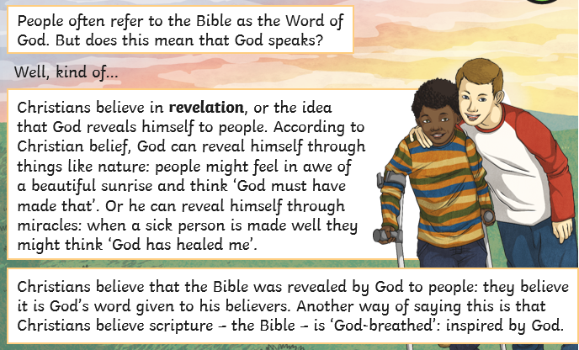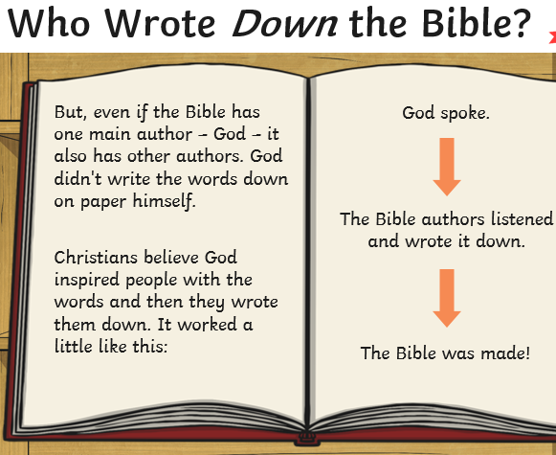

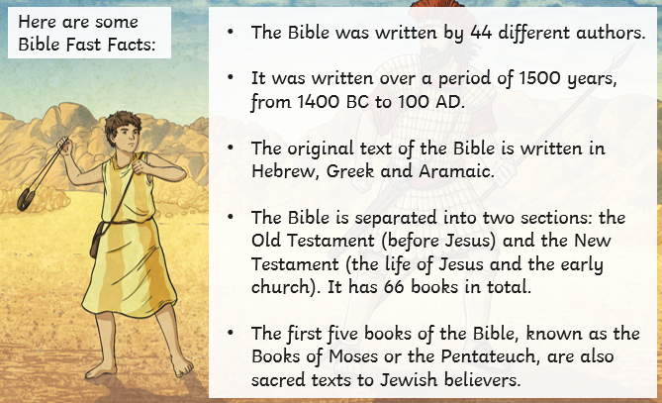
Do you know any other Bible facts?
____________________________
____________________________
____________________________
____________________________

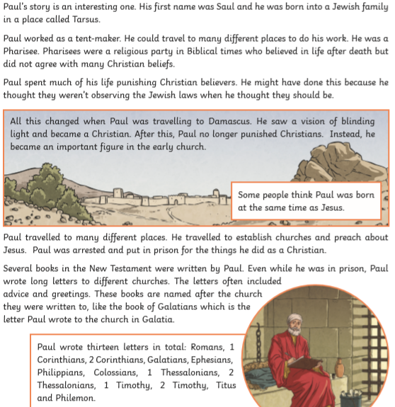
Task 3: With your child read the fact file about an author of the Bible and make notes to prepare for the interview activity to follow.
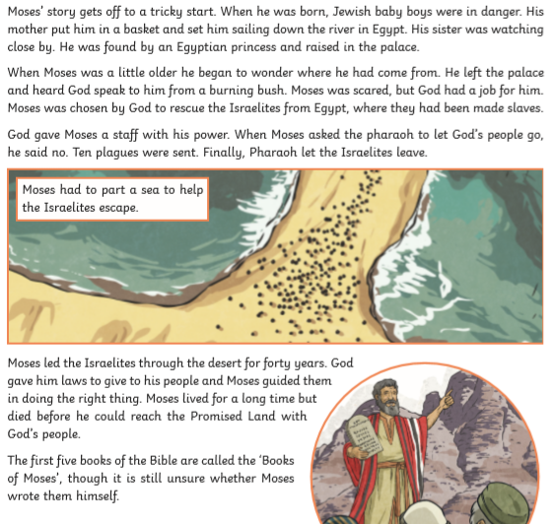
Questions to consider: when and where did they write it? How did they know what to write? Why did they write it? What else can you find out about their life, or the kind of person they might have been?
Task 4: Write an interview for one of the authors above about their writings. You will need to ask the question and then respond in first person. 5 questions in total and 3 must be different than those asked above.
Example: When did you write the books of Exodus? I wrote the books of Exodus whilst…

Challenge question: How are these 2 authors different?

WALT understand how stories are used in the Bible to teach lessons. Lesson 3: The Bible
I can… | Self | Parent
explain what a parable is and why Jesus told them
use my imagination to tell a story in my own way
retell a Bible story to make it relevant to listeners
Task 1: Ask your child if they know any Bible stories. Using the help below, explain that the Bible contains many stories and some have become so well-known that people know the stories without knowing they are actually from the Bible.
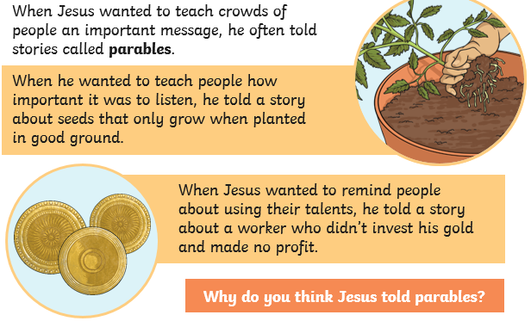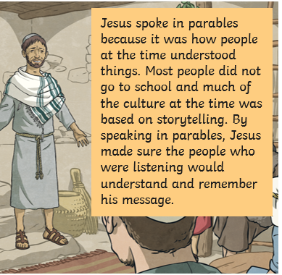
Now read each of the parables below, choose one and re-create it in a comic strip.
