Hello!
I hope you are all well and keeping safe in these very strange times. I am already missing seeing the children’s smiley faces as they arrive into the Nursery each morning. You may have already tried all of the ideas in the home learning packs so I have been keeping myself busy by looking for some more ideas/activities for you to try at home. Please keep checking our Nursery page on the school website for more updates.
I would love to see what you have been doing at home so please upload any photos/videos onto your Tapestry account. If you would like to get hold of me please do not hesitate to email me elake@wadebridgeprimary.co.uk .
Thank you,
Miss Lake

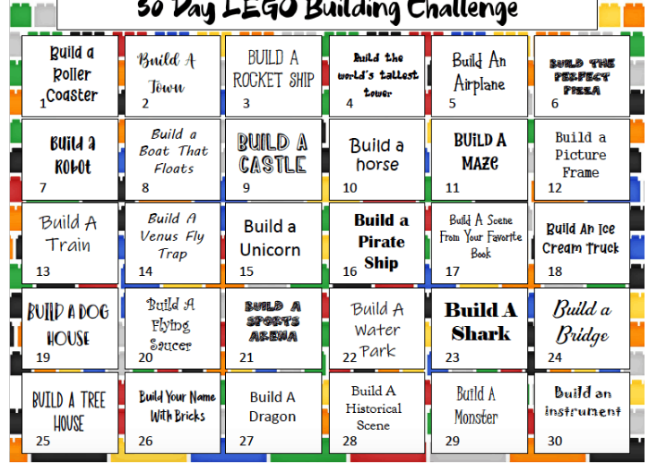
30 Day LEGO Challenge!
These are some great ideas to stimulate your child’s imagination at home. You haven’t got to use LEGO, other construction pieces such as bricks or Duplo could be used too. Construction allows children to be creative and problem solve as they build, learning what works and what doesn’t. Team work, sharing and collaborative play can also be developed through construction when building with siblings and other people in the household. Building also creates many opportunities for children to develop language as they talk about what they have built. Ask them open questions to start a conversation. For example:
“Tell me about who would go in your rocket ship, where are they going…?”
“What could the pirates do on your pirate ship..?”
“What will your monster look like? Tell me about what magical powers/tricks it can do…”
Once built you could add other toys into the play to create stories, role play and small world play e.g. adding animals, cars, people, and teddies.
These ideas link to many areas of the Early Years Foundation Stage curriculum:
Communication and Language: Speaking
22-36 months Uses language as a powerful means of widening contacts, sharing feelings, experiences and thoughts
30-50 months Beginning to use more complex sentences to link thoughts (e.g. using and, because
Uses talk in pretending that objects stand for something else in play, e,g, ‘This box is my castle.’
Expressive Arts and Design: Exploring and Using Media and Materials
22-36 months Experiments with blocks, colours and marks
30-50 months Beginning to construct, stacking blocks vertically and horizontally, making enclosures and creating spaces
Expressive Arts and Design: Being Imaginative
22-36 months Beginning to make-believe by pretending.
30-50 months Builds stories around toys, e.g. farm animals needing rescue from an armchair ‘cliff

Dough Disco!
Playdough has many benefits including sensory play and fine motor. We do a daily dough disco in Nursery. This is to develop the children’s muscles in their hands and fingers to help improve their fine motor development to enable them to have a strong pencil grip. If you do not have playdough at home there is a simple recipe (below) for you to make at home (the children love to help make playdough!!!). You will find many Dough Disco videos on the ‘Spread the Happiness TV’ Youtube channel (they are a little out there but the children love the ‘crazy lady’)
https://www.youtube.com/channel/UCj0shfH3pzhrf3dOrSj_pRw
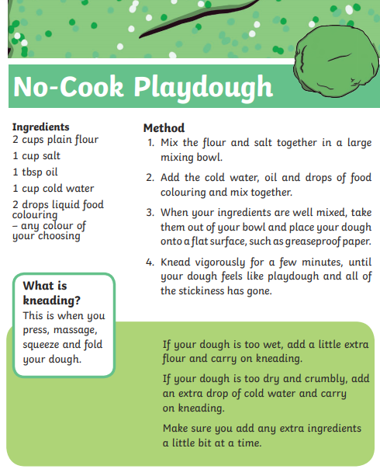

Animals!
There are a number of zoo’s that have set up live webcams so we can see what the animals get up to in their enclosures. You have are able to watch these videos there are some further activities you could try
https://www.edinburghzoo.org.uk/webcams/
https://www.paigntonzoo.org.uk/explore/webcams
https://zoo.sandiegozoo.org/live-cams
- Use pencils/paints/crayons/collage to create a picture of the animals you can see
- Think about what noises the animals make
- Pretend you are the animal and explore how it moves
- Use the internet to find out more facts about the animal https://www.natgeokids.com/uk/discover/animals/general-animals/10-tiger-facts/
- Count how many animals you can see
- Cbeebies have some more videos about animals https://www.bbc.co.uk/programmes/p04gkls9
- Andy’s Baby Animals on Cbeebies
https://www.bbc.co.uk/cbeebies/curations/andys-baby-animals
- You can find some nursery rhymes and songs here about animals
https://www.bbc.co.uk/teach/school-radio/eyfs-early-years/z6bgnrd
These ideas link to many areas of the Early Years Foundation Stage curriculum:
Understanding the World: The World
22-36 months Notices detailed features of objects in their environment
30-50 months Comments and asks questions about aspects of their familiar world such as the place where they live or the natural world.
Can talk about some of the things they have observed such as plants, animals, natural and found objects
Expressive Arts and Design: Exploring and Using Media and Materials
22-36 months Joins in singing favourite songs
30-50 months Sings a few familiar songs
Literacy: Writing
22-36 months Distinguishes between the different marks they make
30-50 months Sometimes gives meaning to marks as they draw and paint
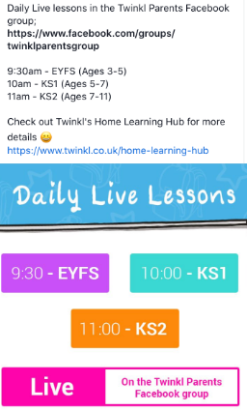
Twinkl
Twinkl have daily live lessons for you to try at home at 9:30am https://www.twinkl.co.uk/home-learning-hub

