Keeping Active!
Hello again,
It is really important to remain as active as you can during this strange period of time for both you and your child. I know it can be very tempting to sit in front of the television all day, but regular exercise can help to lift your mood, improve mental health and help to maintain a healthy body weight.
Below are some ideas about how to keep active both indoors and outdoors with some guidance from Healthy Under 5’s. Healthy Under 5’s recommend children should be active for 180 minutes a day. Of course please be sensible and follow the advice when choosing from the suggestions below (not meeting up with friends, going to the park etc.). Many of the ideas link to the EYFS curriculum which helps to develop your child’s gross motor development.
Physical Development: Moving and Handling
22-36 months
-Runs safely on whole foot
Squats with steadiness to rest or play with object on the ground, and rises to feet without using hands.
-Can kick a large ball
30-50 months
-Moves freely and with pleasure and confidence in a range of ways, such as slithering, shuffling, rolling, crawling, walking, running, jumping, skipping, sliding and hopping
-Runs skilfully and negotiates space successfully, adjusting speed or direction to avoid obstacles.
-Can stand momentarily on one foot when shown.
-Can catch a large ball

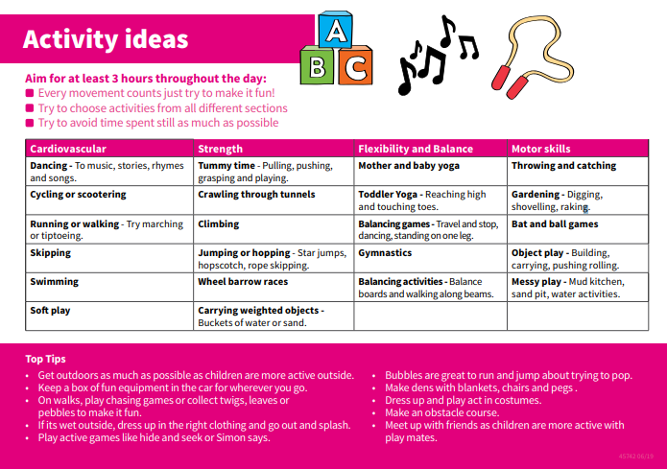
Healthy Under 5s

Change 4 Life
The Change 4 Life website has some great ’10 minute shake up games’
https://www.nhs.uk/10-minute-shake-up/shake-ups#F6DwTDzVH36IGHwX.97
GoNoodle
We use GoNoodle every day in Nursery for our ‘Wake and Shake’. We teach the children about the importance of keeping our bodies fit and strong. The website has a wide variety of dance, yoga and silly videos to move along to.
https://www.gonoodle.com/
Cosmic Kids Yoga
We often do ‘Cosmic Yoga’ in Nursery. Yoga is great for relation, mindfulness and balance. The routines are linked to stories which make them interactive and fun for children.
https://www.youtube.com/results?search_query=cosmic+yoga

Other ideas
