Hello again,
I have collated some more activities/ideas for you to try at home over the Easter Holiday (and will continue to do so over this week and next). I will then be uploading weekly planning starting on April 14th to ensure there is curriculum coverage to enable your child to make progress at home. As ever if you want to contact me via email for further ideas or have any questions please do! elake@wadebridgeprimary.co.uk
Take care and please keep uploading your home learning onto Tapestry- it’s so lovely to see your smiley faces busy at home.
Miss Lake.
The weather
We have been very lucky with the warm spring sunshine over the past couple of days. I hope this has allowed you to spend time in the garden or take your daily exercise walks or bike rides. As the weather becomes cooler again don’t let this deter you from going outside as getting fresh air is very important. Below are some weather ideas and I will upload an e-book about seasons.
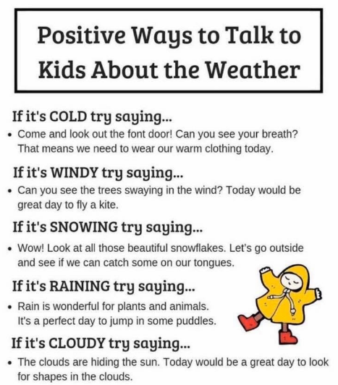
Understanding the World: The World
22-36 months Notices detailed features of objects in their environment
30-50 months Comments and asks questions about aspects of their familiar world such as the place where they live or the natural world.
Can talk about some of the things they have observed such as plants, animals, natural and found objects

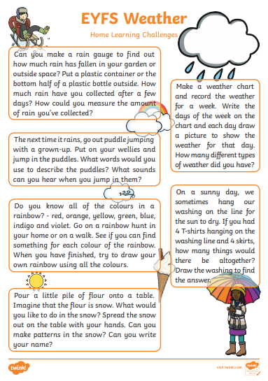

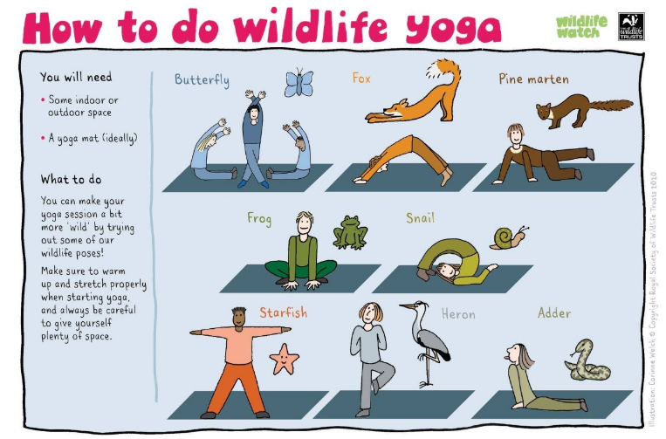
Wildlife Yoga
Physical Development: Moving and Handling
30-50 months Moves freely and with pleasure and confidence in a range of ways, such as slithering, shuffling, rolling, crawling, walking, running, jumping, skipping, sliding and hopping
Can stand momentarily on one foot when shown

Scavenger Hunts
Children love scavenger hunts! They promote discovery and exploratory skills and can be done both indoors and outdoors.
Literacy: Reading
30-50 months Shows interest in illustrations and print in books and print in the environment
Handles books carefully
Holds books the correct way up and turns pages
Communication and Language: Understanding
22-36 months Understands ‘who’, ‘what’, ‘where’ in simple questions (e.g. Who’s that/can? What’s that? Where is.?
30-50 months Responds to simple instructions, e.g. to get or put away an object
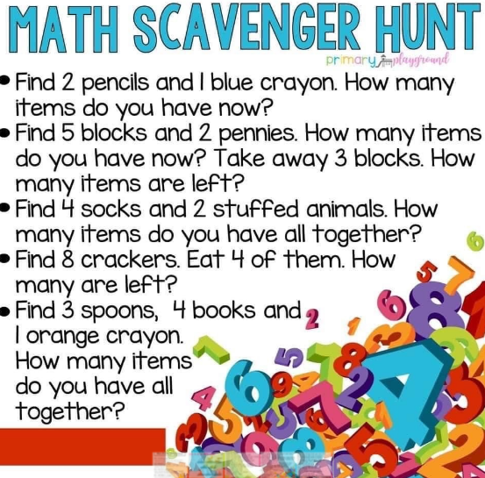
Mathematics: Number
22-36 months Selects a small number of objects from a group when asked, for example, ‘please give me one’, ‘please give me two’
Knows that a group of things changes in quantity when something is added or taken away
30-50 months
Knows that numbers identify how many objects are in a set
Shows an interest in number problems
Shows curiosity about numbers by offering comments or asking questions

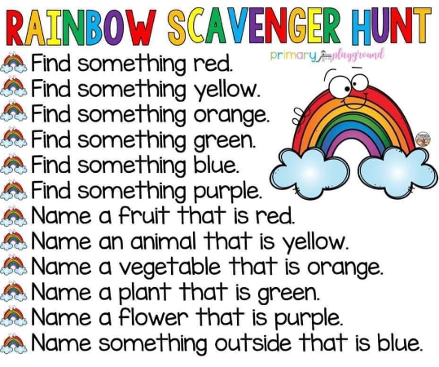
Communication and Language: Listening and Attention
22-36 months
Single channelled attention. Can shift to a different task if attention fully obtained – using child’s name helps focus
30-50 months
Is able to follow directions (if not intently focused on own choice of activity).
