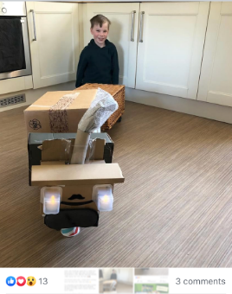
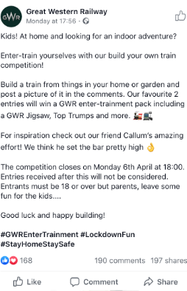
Great Western Railway
This is great competition to do at home as you can use bits and pieces you already have. Cardboard boxes, empty recycling packages, bricks, lego, blocks, cushions, sticks…the list is endless! Let your child’s imagination run with them, you’ll be surprised with what they can come up with. Get creative with decorating your train if you can; paints, pens, glitter, sticky bits, doors, windows, passengers etc.
Please upload any trains you make onto your child’s Tapesty account so I can see.
Have fun!
Miss Lake

