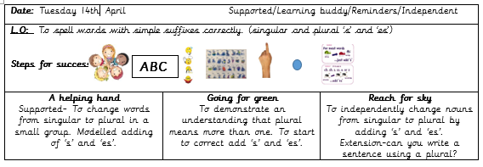

Choose a word taken from one of your favourite reading book. Can you change it to a plural? Can you apply our learnt rule?
Does your word end in one of these sounds?
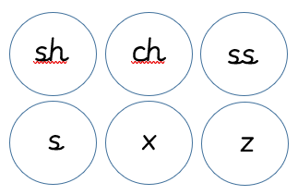

Yes, then add es! No, then just add s.

Can you put these words into sentences?
…………………………………………………………………………………………
…………………………………………………………………………………………
………………………………………………………………………………………..
………………………………………………………………………………………..
………………………………………………………………………………………..
………………………………………………………………………………………..
………………………………………………………………………………………..
……………………………………………………………………………………….
………………………………………………………………………………………
……………………………………………………………………………………….
……………………………………………………………………………………….
……………………………………………………………………………………….
……………………………………………………………………………………….
……………………………………………………………………………………….
……………………………………………………………………………………….
……………………………………………………………………………………….
………………………………………………………………………………………
………………………………………………………………………………………
……………………………………………………………………………………….
…………………………………………………………………………………………
…………………………………………………………………………………………
…………………………………………………………………………………………

