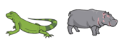
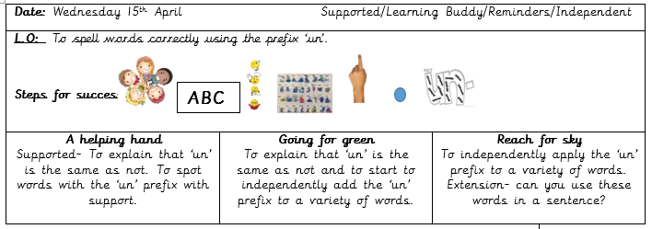
A prefix comes at the ………………………………………. of a word.
It means …………………… .
Can you add the ‘un’ prefix to change the meaning of the word?
do | comfortable | certain
Able | fair | usual
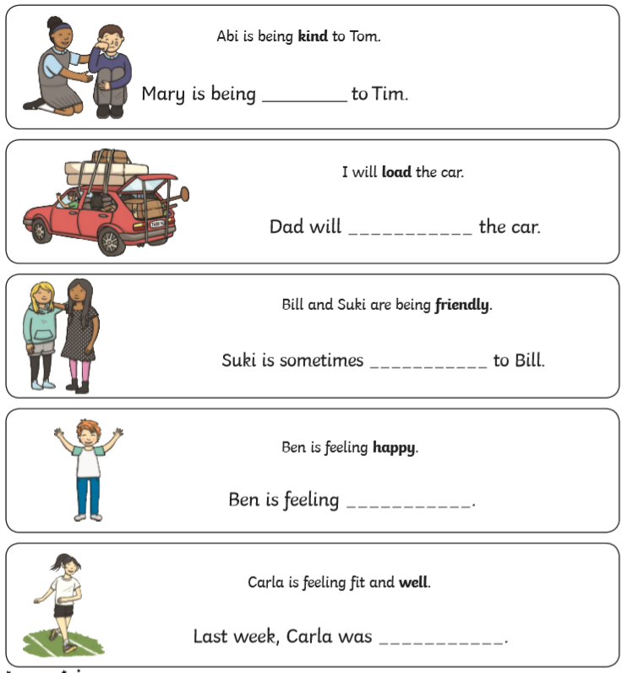

Can you think of any of your own words that start with the prefix ‘un’?

