Can you match the word to its partner with the ‘ing’ suffix?
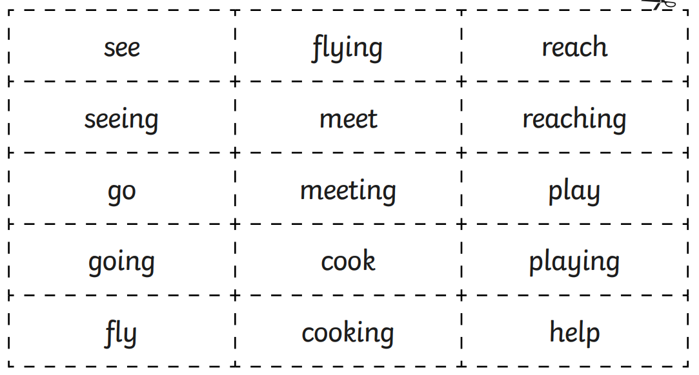

Can you match the word to its partner with the ‘ed’ suffix?
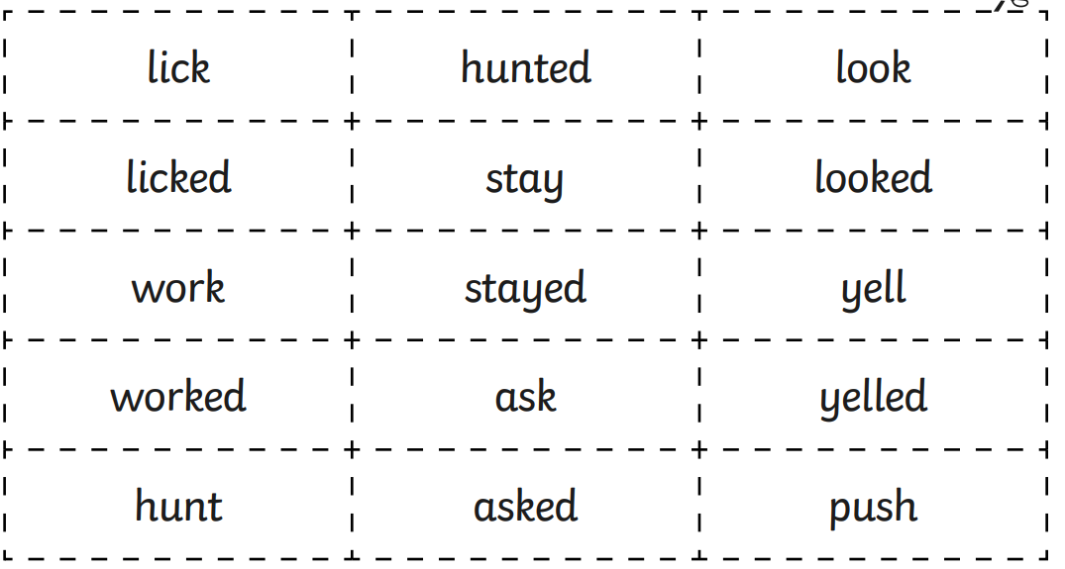

L.O: To spell words with simple suffixes correctly adding –ing, -ed
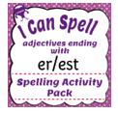
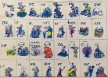
Steps for success:
ABC

Can you sort the words into the different suffix categories? Can you record and underline the suffix?
ing | ed
singing | worked

Can you underline the words with a suffix?

She was taller than the mermaids. She was singing to the crowd.

