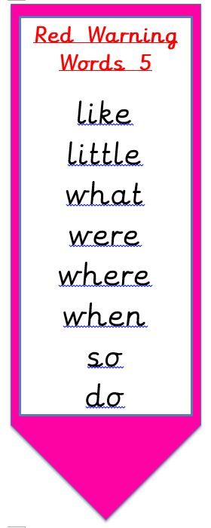

shout

plouck

out

stouw

mountain

blouff

loud

whouth

found

