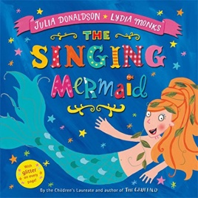
Topic Ideas- Year 1 Summer Term

Please do continue to create your own 'mini projects' following an interest of your choice. For example you may have an interest in Mermaids- you could make a fact book, design a mermaid costume for your teddy etc. This can be completely your choice so feel free to be as creative as you wish using the resources that you have at home.

Here is a list of other ideas and activities you may like to have a go at. Please do as many or little of these as you like. You may also have lots of different ideas!

- Researching:
Can you research a famous pirate?
Can you research and answer the question-are mermaids real?
Is there really buried treasure at the bottom of the ocean?
What kind of strange and mysterious creatures are in the deepest darkest parts of the ocean?
- Seaside Music –. Make your own musical instruments using junk. Use your instruments to make seaside music.
- Painting and sketching – Paint a picture of a mermaid. Draw or sketch a sea side picture.
- Bug hunts – go on a bug hunt in your garden.
- Create a beach picture using things you find in the garden.
- Make a puppet show.
- Design a new circus.

