Week 6 Spellings – W/B 18.05.20
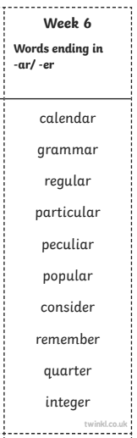

Write them....

In different colours As a crossword

Backwards

In dots
As a rainbow

In a wordsearch
In sand

Using magnetic letters

In a spiral

