Nursery Planning- Harry and the Dinosaurs have a Happy Birthday
Week 6: Summer 1
(don’t forget to scroll down for additional activities and daily phonics)
 | Literacy/Understanding the World | Maths
Monday  18th | This week we are looking at the story of ‘Harry and the Dinosaurs have a Happy Birthday’. Log onto your Tapestry account to listen to Miss Lake read the story. After listening to the story consider asking questions about what happened? Who was the story about? Who were the characters? What did Harry do? Can you tell me what happened at the birthday party? Who as it for? Which was your favourite part of the story-why?  Challenge: Can you draw a picture of Harry and his dinosaurs having a birthday party? What will there be at a party? Will there be anything special to eat? | Numberblocks:  Video: Four (found on iPlayer) https://www.bbc.co.uk/iplayer/episode/b08d61cv/numberblocks-series-1-four  Activity: Watch the video first. Ask your child about the video. Now can they go and find 4 of the same object? Are they able to correctly count each object? Model how the number 4 can be made by adding 1s together. Draw a little square (1) add one next to it (2) and then underneath (3) and then (4) this is so it makes the same shape as the Numberblock number 4. Encourage your child to count each one as you draw them. If you have little blocks you could make a Numberblock.  Challenge: Go on a number hunt, can you find any number 4’s in your house?
Tuesday  19th | It’s party time! Today you are going to throw a party for your special toys/teddies. With your child show them how to write a list and explain that you write things down in a list so you don’t forget them. Ask them to think about things you need for a party (certain foods/drinks, decorations, cards, presents, party clothes etc.) Encourage your child to make marks/draw pictures next to the words to contribute to the list. Together decide how you might make some decorations/cards to make it look like a party. You could even bake a cake. Have fun!  Challenge: Don’t forget to invite your guests! Can you make some party invitations for your party? Don’t forget to write your name so they know whose party it is. | Numberblocks:  Video: Five (iPlayer) https://www.bbc.co.uk/iplayer/episode/b08d630h/numberblocks-series-1-five  Activity: Watch the video first. Ask how 5 was made. What things did 5 see and count? Talk about things that have 5 (fingers, toes, star points). You could sing the song of 5 Little Ducks and encourage your child to show the correct amount of fingers. Provide an opportunity to show how 5 can be made with 4+1 (like the video). You could start with 4 bricks and add another to make the Numberblock 5. Notice, when you ask your child to count the objects now can they add one more on by saying ‘5’ or do they count them all again?
Wednesday  20th | Can your children remember any of the names of the dinosaurs from the story? Can they describe what they look like? Or what they do? Look through the ‘Wed-Dinosaur names’ Powerpoint together to learn the names of the dinosaurs. Talk about what they look like and their features e.g. “Can you tell me about what this dinosaur looks like…?”. Have they seen the dinosaur before? Are they able to tell you any facts about the dinosaur?  Challenge: Can you draw your favourite dinosaur? What features does it have? A long neck? Wings? Horns? What about what colour you think it might be? | Numberblocks:  Video: Off We Go (iPlayer) https://www.bbc.co.uk/iplayer/episode/b08cr0y7/numberblocks-series-1-off-we-go  Activity: Watch the video first. Discuss with your child what they saw. Draw and cut out some Numberblock characters (1-5). Allow your child to familiarise themselves with them. Muddle them up as you place them in a line. Ask your child if they think they are in the right order. Allow them to try and put them in the correct order. As they do use mathematical language like “2 is before 3, 3 is before 4, 3 is just after 2” as they arrange them. Encourage them to use this language too. Repeat activity as needed.  Challenge: Can you make mark/write the numbers to match each Numberblock? (or make number cards to match)
Thursday  21st | Dinosaur swamp gloop! To make a dinosaur swamp you will need to mix up some gloopy gloop by mixing cornflour (or cornstarch) and water together with a bit of green food colouring. You need to add one cup of water to every two of cornflour. Do this in a washing up bowls/tray. Encourage your child to make marks in the gloop either by using their finger, tools like spatulas/spoons or dinosaur toys etc. Can they draw a dinosaur? Or make dinosaur foot prints? Can they make any patterns? Can they write any letters of their name? | Numberblocks:  Video: How to Count (iPlayer)  https://www.bbc.co.uk/iplayer/episode/b08cr24d/numberblocks-series-1-how-to-count  Activity: Watch the video first. Ask your child about the video and what they noticed (the flapjacks counted in the wrong order). Have 4 objects and say you are going to count them. On purpose count them incorrectly (1,2,4,3). Ask your child of you are right, repeat again counting incorrectly (1,3,4,2). Ask if you are right again. Encourage your child to ‘help’ you to correctly count them in order. Continue to repeat to practise counting in the correct order.
Friday  22nd | Enjoy listening to and joining in with ‘Fri-Harry’s Bucket Song’ and ‘Fri-You’re a Dinosaur and you Know it’. Maybe you could dress up like a dinosaur and make masks? | Numberblocks:  Video: Stampolines (iPlayer) https://www.bbc.co.uk/iplayer/episode/b08dnngm/numberblocks-series-1-stampolines  Activity: Watch the video first and discuss together what you saw.  New learning: subitising. This means being able to recognise a small amount of objects without counting them e.g. dots on a dice. This is help children understand it can still be the same number even if it has a different arrangement. Look on ‘Fri-Maths’ for todays activity.  Challenge: Can you have a go at the ‘Fri- subitising dice’ game. Are you able to tell me the number without counting the dots?
Additional activities
These are some further ideas that link to the story on each day. They are a great way of extending your child’s learning or to develop their interests further. The instructions can be found in separate named documents.
Monday  18th | Tuesday  19th | Wednesday  20th | Thursday  21st | Friday  22nd
Make your own dinosaur fossil by following the instructions ‘Mon-make your own fossil’. Talk about how fossils give us clues about the past and that dinosaurs live a very long time ago. When they die mud/rocks cover it up and that’s how you get a fossil. | 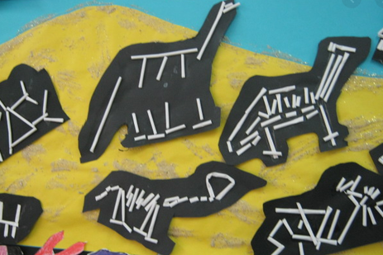  Practise those scissor skills by snipping cotton buds or straws to make dinosaur skeletons. | Can you dance like a dinosaur to one of our wake and shakes? ‘Dinosaur Stomp’ https://www.youtube.com/watch?v=Imhi98dHa5w | 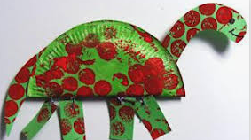  Paper plate dinosaur craft | Fill balloons with coloured water and then place a small dinosaur inside the balloon. Once frozen, peel the balloon off and put the ice balls (or ‘dinosaur eggs’) into the water tray to explore. Provide water pistols or sprayers containing warm water to investigate the properties of melting ice.
Make and cut out some large dinosaur feet and write numbers on then. Challenge your child to put them in order, recognise the numeral or count objects to match the numeral. | Explore Andy’s Adventures on Cbeebies. | 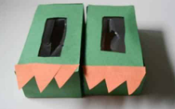  Use old boxes and turn them into dinosaur feet! | Listen to BBC School Radio- Dinosaur Song  https://www.bbc.co.uk/teach/school-radio/nursery-rhymes-dinosaurs/zv7rf4j | 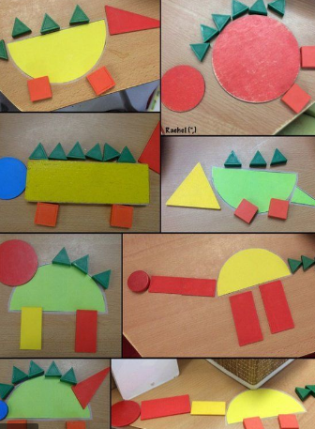  Cut out some shapes and encourage your child to make a 2D shape dinosaur. Can they tell you the name of the shapes they are using?
Phonics
Below are some daily phonics ideas that will enable your child to practise and develop the skills they have learnt so far this year
Please visit phonicsplay.co.uk- Parents- Pre-school children for some really helpful support about how what phonics is, how it is taught and further ideas.
Monday  18th | Tuesday  19th | Wednesday  20th | Thursday  21st | Friday  22nd
Go to Twinkl.co.uk. They will allow you to access some free resources (Phase 1)
Oral Blending and Segmenting https://www.twinkl.co.uk/resource/t-l-52383-farm-themed-oral-blending-and-segmenting-phonics-picture-hotspots  Today you will be practising how to orally segment and blend words (robot talk). Ask your child to listen carefully as they click on each hotspot and then repeat. You may need to model how to do this. You can use robot arms to move each time you make each sound. | Environmental Sounds  https://www.twinkl.co.uk/resource/t-t-21902-wheres-teddy-listening-game-resource-pack  Today you will be practicing your listening skills. You will only need to download the Powerpoint. Ask your child to turn their listening ears on. Maybe ask them to close their eyes as they listen to the sound. Ask them to describe what they can hear. Have they heard it before? Where have they heard it before? | Oral Blending and Segmenting https://www.twinkl.co.uk/resource/t-l-6232-seaside-themed-blending-and-segmenting-phonics-picture-hotspots  Today you will be practicing how to orally segment and blend words (robot talk). Ask your child to listen carefully as they click on each hotspot and then repeat. You may need to model how to do this. You can use robot arms to move each time you make each sound. | Rhyming  https://www.twinkl.co.uk/resource/t-l-53569-phase-1-phonics-rhyming-picture-hotspots  Today you will be looking at rhyming. Can your child think of any other words that rhyme with the hotspot words? Practise saying them together. | Oral Blending and Segmenting https://www.twinkl.co.uk/resource/t-l-53165-robot-robbie-posting-busy-bag-prompt-card-and-resource-pack  Today you will be practicing how to orally segment and blend words (robot talk). (You may like to make your own robot from a cardboard box and print out the pictures to post if you can). Use the picture cards to segment and blend the word. Model first and encourage your child to join in/copy.
Oral segmenting and blending:
Robotic talking - Words are made up from sounds (called phonemes) and children need to be able to hear these sounds individually. Sometimes when you are playing you can say words as if you were a robot (saying the sounds separately) and see if your child can work out what you are saying. Stick to short simple words that only have a few sounds in them. Make sure you are saying the letter sounds (p-i-g) not the letter names (pee-eye-gee). If you aren't sure what the sounds are or how to break that word down then just miss out that word and pick something easier. E.g.
Pass that p-i-g to me.
Sit d-ow-n.
Point to your t-ee-th.
Hop like a f-r-o-g
As your child becomes familiar with this robot talking, see if they can say words in robot talk themselves?

