Friday Maths
- Ask your child to look at each shape and ask
“Which Numberblock do you think has made each shape-how do you know?”
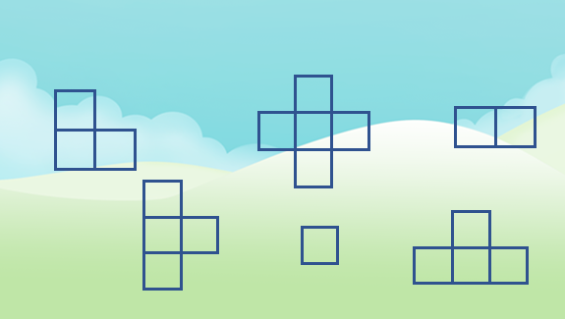
- Compare two shapes and ask about the similarities/differences between the shapes (e.g. it has 1 more block than this shape)

- Now discuss which one of these is the odd one is out. Ask your child why they think it is the odd one out to understanding their thinking. Is there more than one answer?
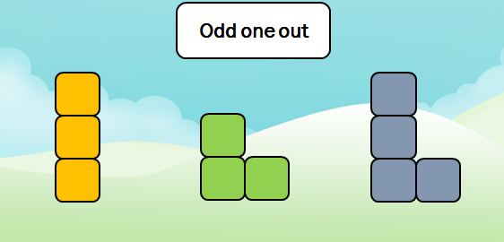

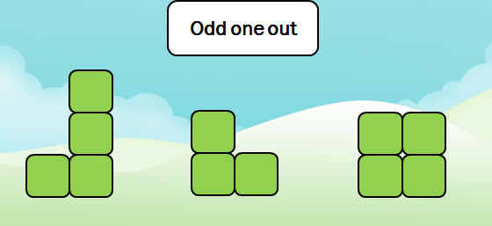
- Now ask your child “How many stars are there?”

Ask them again….(are they able to tell you without counting?)

And again “Are there still four?”

And again…

You could also try this was actual objects by moving them around into different arrangements to understanding the quantity is the same even though it look different. If you have a dice at home play encourage your child to roll it and tell you how many dots there are. Encourage them to tell you the number rather than counting each time. You could link an action to the number e.g. if you roll a 4 you could do 4 star jumps.

