One for the sea
Two for the tide
Three for a donkey
Four for a ride.
Five for a sea-gull
Flying up high
Six for summer
And a bright blue sky
Seven for a castle
Built of sand
Eight for an ice-cream
In my hand.
Nine for holidays
In the sun
Here at the seaside
Ten for FUN!
© to Brenda Williams

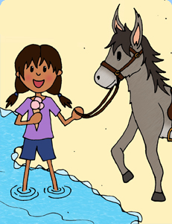

Dandelion yellow
Dandelion bright
How did you turn so
Fluffy and white?
Here in the hedgerow
Once dressed in gold
Your head has turned silver
Your petals grown old.
Now as I blow
To make dandelion time
Your parachutes fly
And I hear your clock chime.
One o'clock, two o'clock
Count out the sound
Watch the white angels
Float to the ground.
Here near the meadow
You'll grow once again
And then I will find you
In Dandelion Lane
© to Brenda Williams
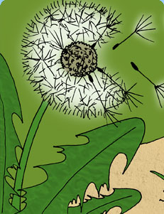

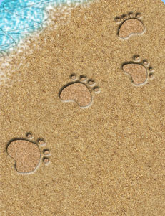
Footprints trailing in the sand.
Leaving little clues
Of people walking barefoot
And others wearing shoes.
Flip-flops or trainers
All with different soles.
Making pretty patterns
Of little dents and holes
Barefoot prints of tickled toes.
Heels, firm and strong.
Some are short and narrow.
Others wide and long.
Tiny baby footprints
Where toddlers tried to stand.
Perfect padded paw prints
Of dogs that raced the sand.
Kite-shaped, zig-zag tracks
Of waddling gulls webbed feet
Leave tell-tale signs along the beach
Of where they like to eat.
Big prints. Small prints.
Following in a line.
Looking back across the beach,
Some of them are mine!
© to Brenda Williams

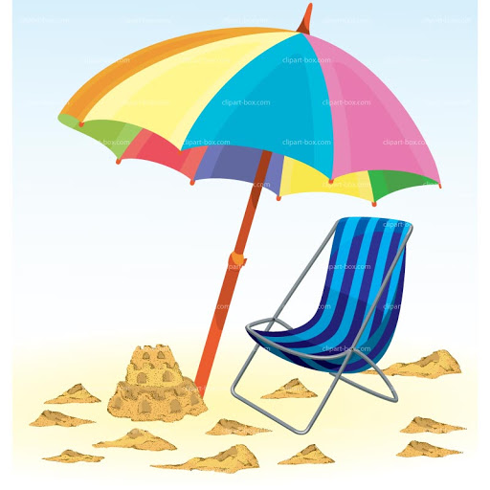
One warm sea
Where I can splash.
Two huge rocks
Where waves can crash.
Three sand castles
I have made.
Four blue buckets
Near my spade.
Five pretty pebbles
I have found.
Six shiny shells
Lying around.
Seven happy children
Playing with a ball.
Eight big sea-gulls
Screech and call.
Nine little sailing boats
Bobbing in the bay
Ten loud cheers
For our holiday!
Hurray! Hurray! Hurray! Hurray! Hurray!
Hurray! Hurray! Hurray! Hurray! Hurray!
© to Brenda Williams

Listen
Said the waves
Swishing on the sea.
Listen to me splashing on the sand.
Listen said the waves.
Listen
Just to me.
Listen
Said the boats
Bobbing on the sea.
Listen to the flapping of my sails.
Listen said the boats
Listen
Just to me.
Listen
Said the sand
Squelching near the sea.
Listen to your footsteps as you walk.
Listen said the sand
Listen
Just to me.
Listen
Said the wind
Whooshing near the sea.
Listen to my whistling and wails
Listen said the wind
Listen
Just to me.
Listen
Said the gulls
Screaming near the sea
Listen to me calling as I fly.
Listen said the gulls
Listen
Just to me.
Listen
Said the beach
Lying near the sea
Listen to them all as they speak
Listen said the beach
Listen
To the sounds near the sea.
© to Brenda Williams

Waves from the sea
Splash on my toes,
Swirl round my knees
And tickle my nose.
Sand from the beach
Slips through my toes,
Sticks to my knees
And hides in my clothes.
© to Brenda Williams

Published by Scholastic

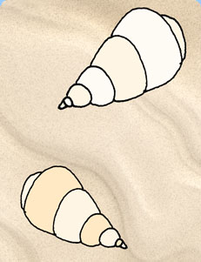
The beach is a treasure chest
Of pearl and silver shells,
Some smaller than my finger nail
Like tiny orange bells.
Large flat fan shapes
In white and yellow tones.
Pretty, swirly, curly shells.
Shaped like ice-cream cones.
Pink and cream crab shells,
Some still with their claws,
Cast off by their owners
And swept up on the shores.
Blue and green jelly fish,
Stranded on the beach.
Only look, but never touch!
Stand well out of reach.
Small, rough, rugged rocks,
Glistening in the light.
Smooth silky pebbles
In black, grey or white.
Sunbleached, drift-wood
Scattered on the sands.
Carried far across the seas
From near and distant lands.
The beach is a treasure chest
With many kinds of jewels,
Like diamonds shining in the sands
Or hiding in rock pools.
© to Brenda Williams

