**Red Warning Words 6**

out

one

there

looked

called

asked

people

please

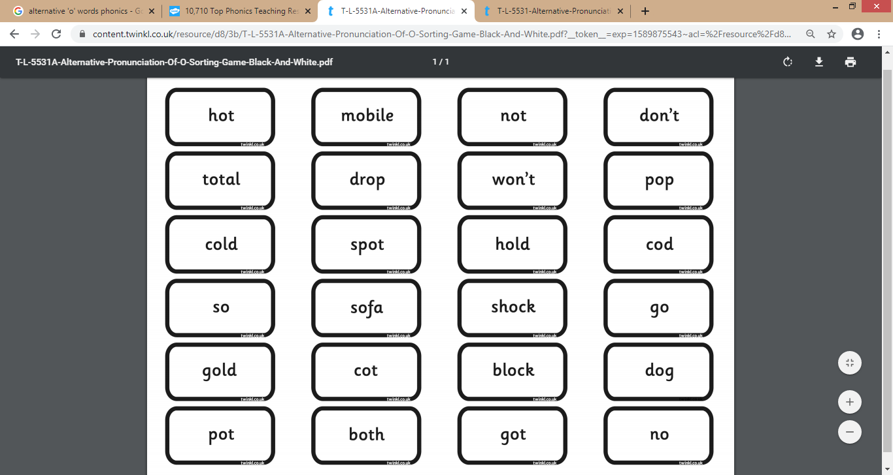

Choose 2 colours.

Colour all words using ‘o’ (as in dog) in one colour.

Colour all words using alternative ‘o’( as in ‘go’) in a different colour.