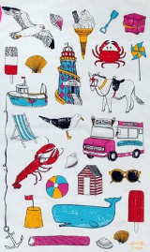
Describing a seaside object
We are creating a word bank using our senses to describe a seaside object. Think about how the object looks, feels and might sound?

Seaside Object | How does it look? | How does it feel? | How does it sound?

