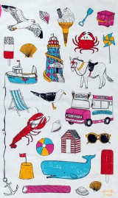
Describing a seaside object
We are creating a word bank using our senses to describe a seaside object. Think about how the object looks, feels and might sound?

Seaside Object | How does it look? | How does it feel? | How does it sound/smell?
Seaweed | Green | Slimy and slippery | Salty
Shell | Colourful | Smooth and hard | Sounds like the waves
Sand | Yellow | Soft | Crunchy
Pebbles | Grey | Rough | Salty
Waves | Strong | Powerful | Salty
Boats | Small | Smooth | Loud
Seagulls | Large | Feathery | Squawking

