**Red Warning Words 6**

out

one

there

looked

called

asked

people

please

Choose 3 colours.

Colour all words using ‘y’ (as in yet) in one colour.

Colour all words using alternative ‘y’ making the ie sound (as in ‘why’) in a different colour.

Colour all words using alternative ‘y’ making the ee sound (as in ‘smelly’) in your final colour.

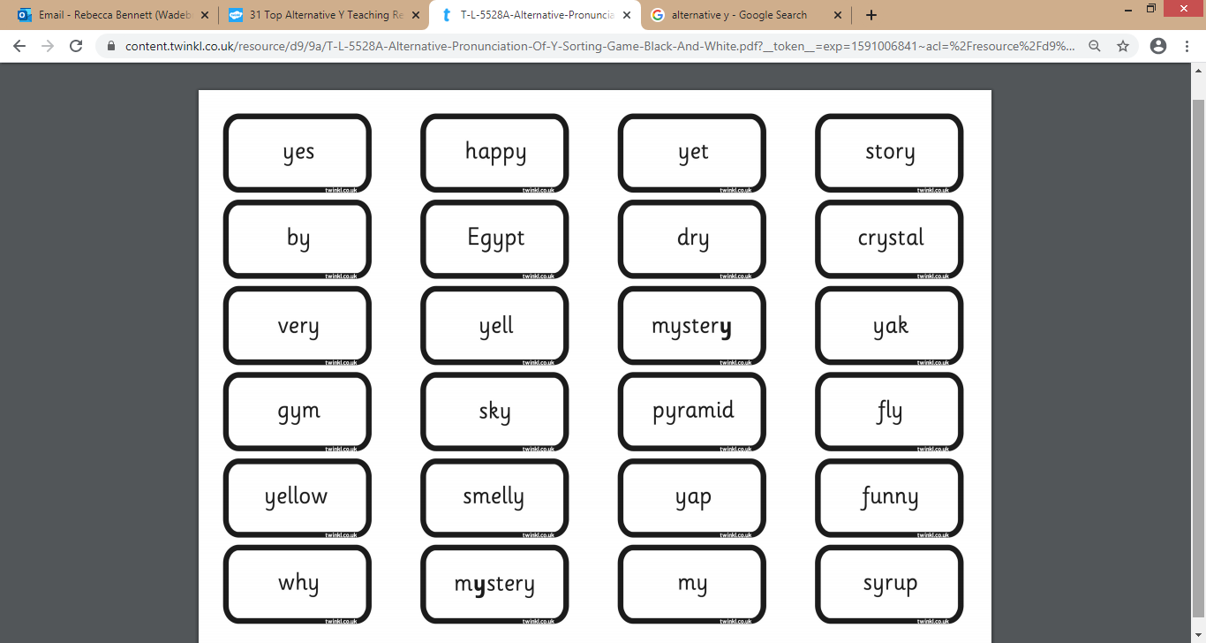

**runny**

**mummy**

**year**

**fry**

**cry**

**sky**

**mummty**