Alternative ‘ch’ sounds
Can you sort the words into the correct boxes?
ch | ch (sounds like c) | ch (sounds like sh)

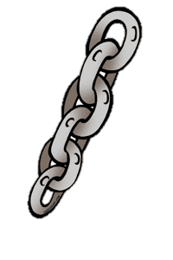
chat school chef chin chord chalet chop chemist
machine chain Christmas parachute echo reach

Can you put the word ‘school’ into a sentence?

Can you put the word ‘chef’ into a sentence?

