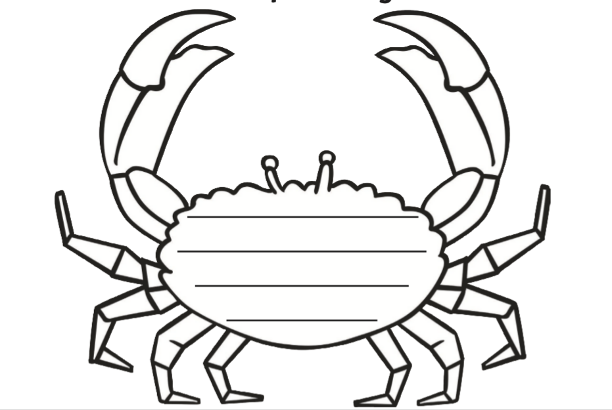

Clipperty-clap the crabs claws snap

His eyes on stick like stalks

He has ten spikey long legs

And a hard shiny shell that he carries when he walks!