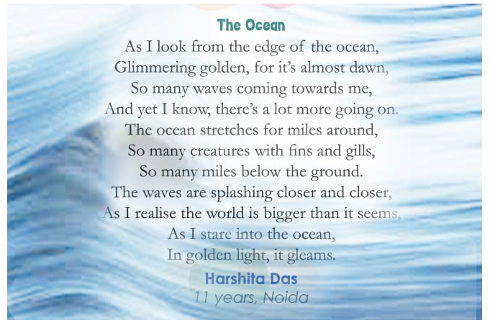
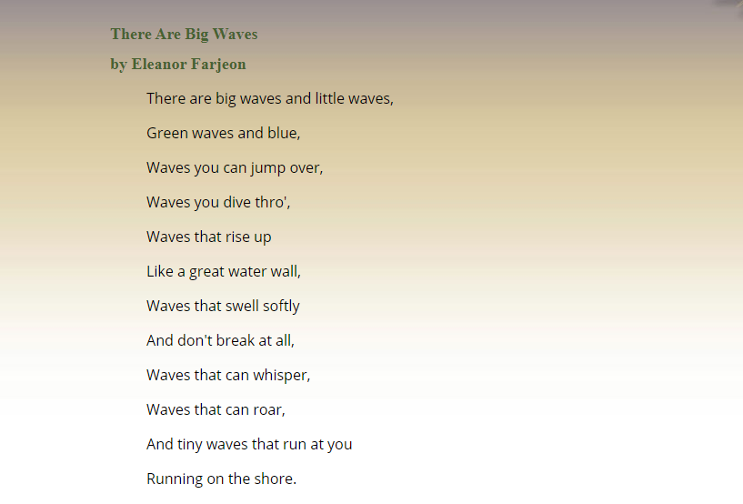

Michael Rosen- Salty Wave
https://www.youtube.com/watch?v=0VU-Huz6yrc

Wave sounds
https://www.youtube.com/watch?v=Xfks6jiS_iI
Stormy waves
https://www.youtube.com/watch?v=-i8IMw5WeXc

