Tuesday 23rd June

**Red Warning Words 6**

out

one

there

looked

called

asked

people

please

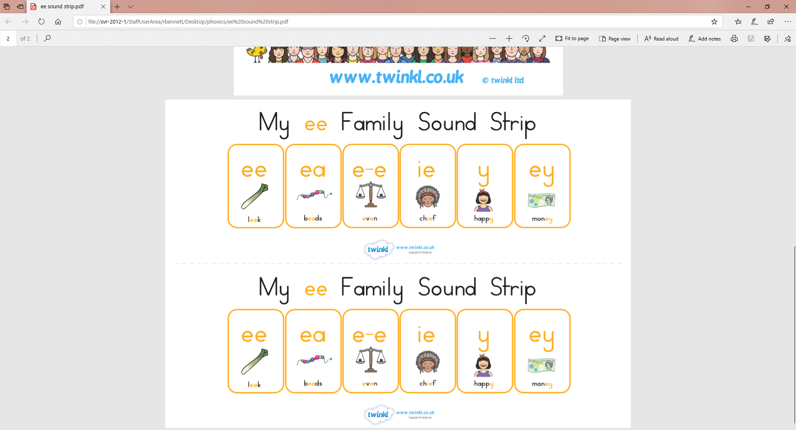

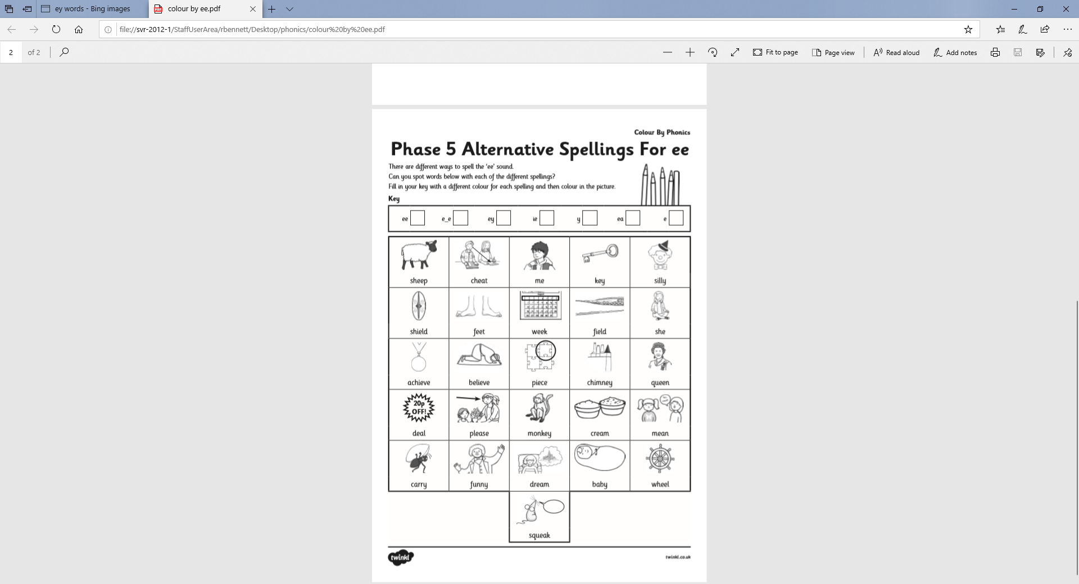Tuesday 23rd June

Can you spot the different ways of making the ‘ee’ sound?