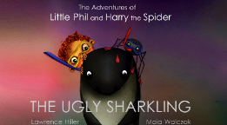
I can draw a story map for the ‘The Ugly Sharkling’ story.

