I can adapt some key features of a story to help me plan my own version of ‘The Ugly Sharkling’.
The Ugly Sharkling Story | My Story
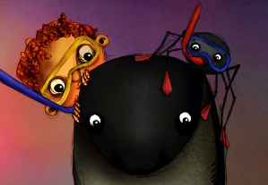  Characters  Phil  Harry the spider  Norman the shark | Characters
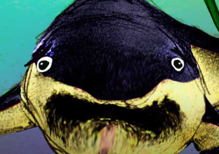  The problem  Norman has no teeth! | The problem
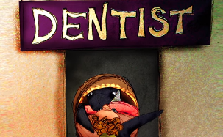  The resolution  Norman disguises himself as a baby and visits the dentist. | The resolution

