Thursday 9th July

**Red Warning Words 7**

oh

their

Mr

Mrs

would

should

could

friends

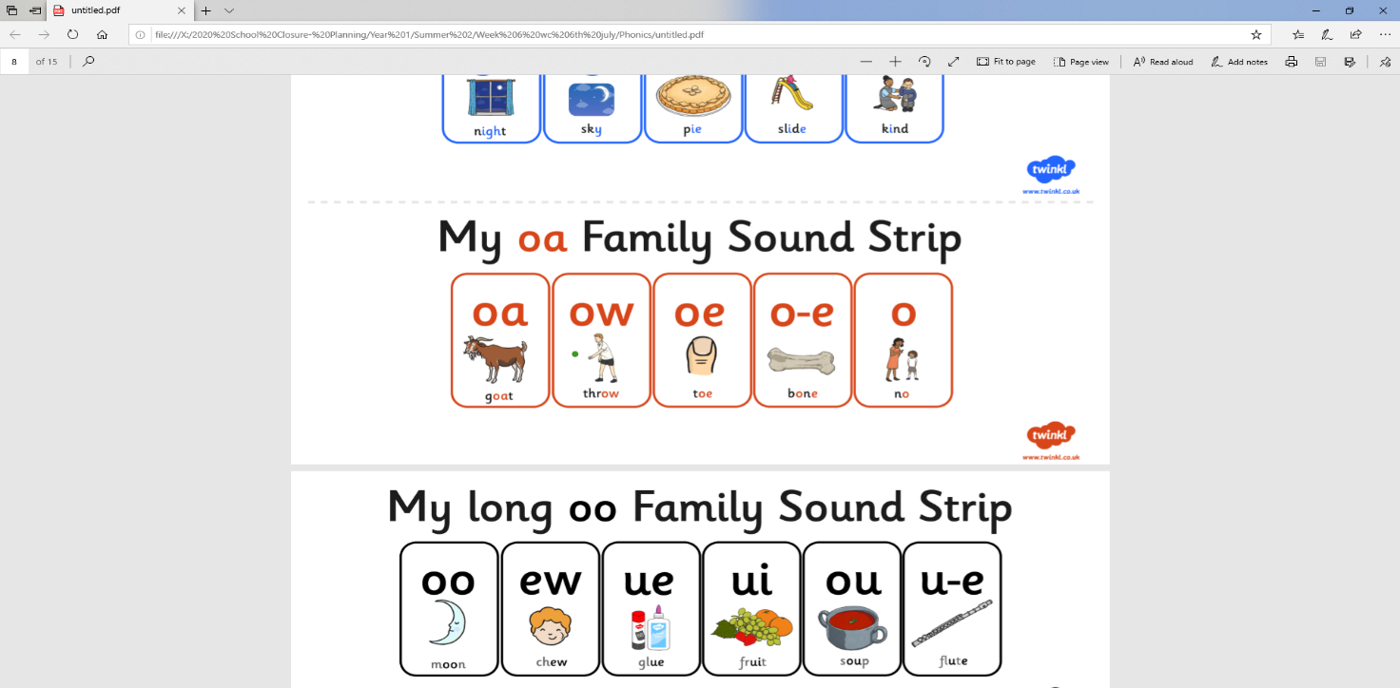Thursday 9th July

Read the story about The Old Pony. Once you have read it, complete the activity sheet on the next page.

