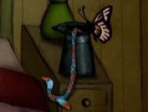
I can use my imagination in my writing to write a description of the items I would like to come out of my magic hat!

Item | Description | Illustration

