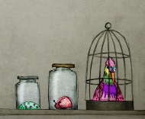
I can consider different views and write my own opinions.
Reasons why people might think animals should not be kept in cages….
I think that…..
Reasons why people might think animals should be kept in cages…

