Optional Home Learning Grid
Year Group: 6 Topic: WW2 Term: SPRING
Throughout the term, please choose from these learning tasks below. Learning can be recorded in many ways so please be creative! You may choose to record your learning by taking photographs or videos and emailing them to your teacher. Please bring your home learning to school so that it can be displayed and shared with your friends.
Art:  Complete a front cover for your topic book.  Draw a dinner menu only using ingredients available during rationing.  Design a safety propaganda poster telling people how to stay safe during the blackout. | 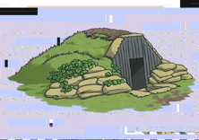  D and T:  Build an Anderson shelter  Draw and label a plane or tank from the Second World War.  Design a Second World War themed game.  Make do and mend; create an item (maybe a bag or toy) using only recycled materials. | Science:  Create a periscope  Design and test out a parachute (using a toy or weight) that would allow a member of the RAF to land safely.
Geography:  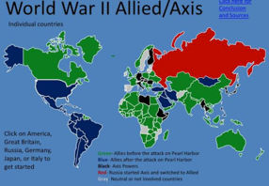  Draw or trace a map of the world and mark the countries which were involved in the Second World War. | History:  Talk to relatives about members of your family who were alive during the Second World War. Share any exciting stories with the class!  Write 10 facts about how life has changed since the 1940s.  Research and write 10 facts about Anne Frank. | Maths:  Bake or cook a wartime recipe (remember to carefully weigh and measure your ingredients). Try and include some ratio in your recipe by scaling it up and down for other quantities.  Design a gas mask box: you will need to make a net for a cube or cuboid to construct it.
Working with others:  Play a game of battleships with a friend or family member.  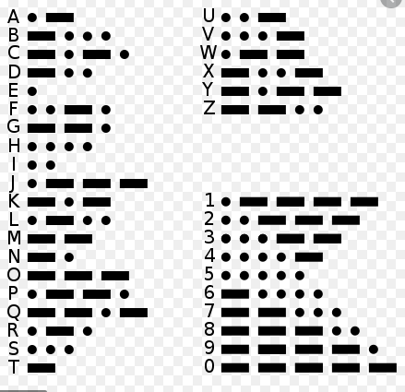  Write a message to a friend or family member using Morse code. | ICT:  Design your own code with a family member or sibling and write messages to each other.  Watch a WW2 themed film – Goodnight Mr Tom or Carries war are great.  P.E:  Research and play outdoor games which would have been played by children in the 1940s. | English:  Imagine you have been evacuated. Write a letter home to your parents.  Read a Second World War novel and discuss with a friend of family member. This could be letters from the lighthouse, Grandpas Great Escape, Carries war, Goodnight Mr Tom to name but a few!  Write a newspaper report about a significant event during  the Second World War.

