Homework set on Friday 25th September 2020
Bring back to school by Thursday 1st October 2020
Maths – LO: To identify and represent numbers to 1000 and beyond.
Use your place value knowledge to find different ways of representing the numbers below. You can represent the numbers using number lines, partitioning, counters, Numicom, multiplication, or by drawing coins. The first one has been done for you.
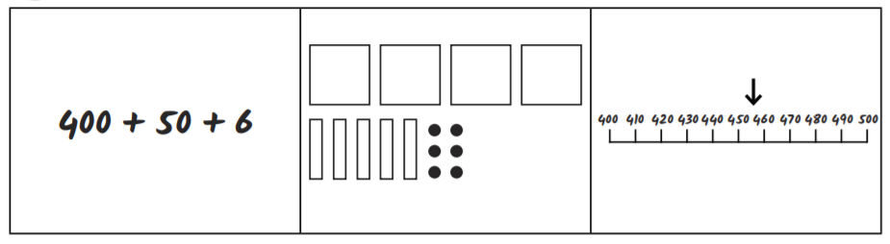
456
745

142

1580

64

4320

8040

