30.11.20 Spellings
Here are your spellings for this week!
Please find some time to practice them at home.
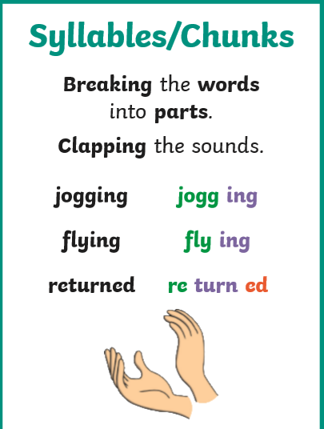
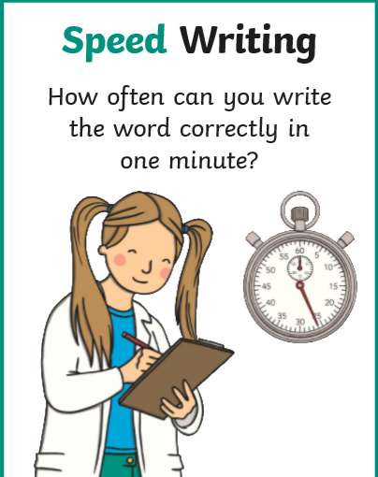
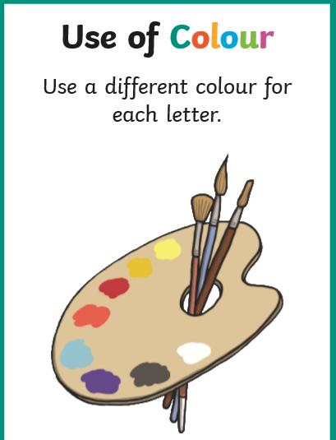
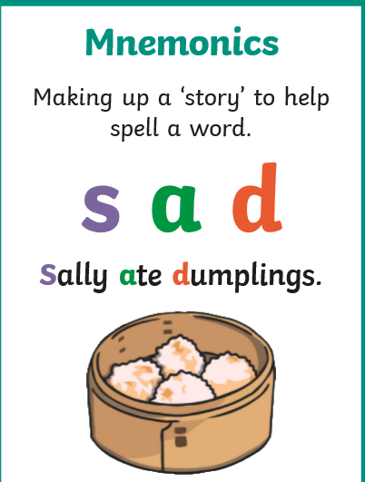
basically
frantically
dramatically
magically
tragically
comically
actually
accidentally
occasionally
eventually

Can you write some sentences using some of these words?

