Optional Home Learning Grid
Year Group: One Topic: What does it take to be an ice explorer? Term: Spring One
Throughout the term, please choose from these learning tasks below. As we will be only exploring this topic for the first part of Spring term, we have shortened the list of tasks. Learning can be recorded in many ways so please be creative! You may choose to record your learning by taking photographs or videos and emailing them to your teacher.
History:  Can you research a famous explorer? It doesn’t have to be someone that explored in the ice!  Create a fact file about your explorer to share with the class. | D and T:  Using Lego/ Junk modelling, can you create a machine that could travel through snow? You may wish to research ‘Snow mobiles’ to help you design and build your machine.  Bring your design and model in to school! | Science:  Have a go at the ‘Picking up an ice cube’ experiment on the back of this page. Write about your findings!
Geography:  Can you write a list of the differences between the Arctic and Antarctica? With the help of an adult, watch this video to show you the differences  https://www.youtube.com/watch?v=b1h-9TSu4wE  You could create a venn diagram to show the differences, like in the picture below.  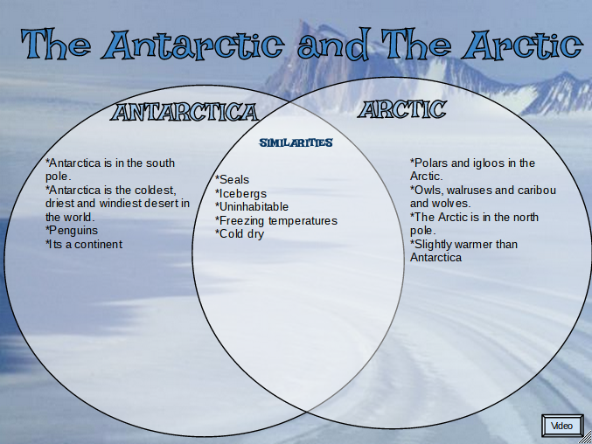 | Art:  Can you mix different shades of blue paint? Explore how you can make the blue darker and lighter. Using your ‘blues’, create an ice picture | Art:  By exploring the properties of freezing water, can you create your own natural ice art work, like in the picture below? You can use twigs, leaves, flowers etc.  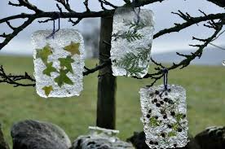  Obviously you won’t be able to bring this in to school, but please do send us pictures! You could write some instructions for a friend!

