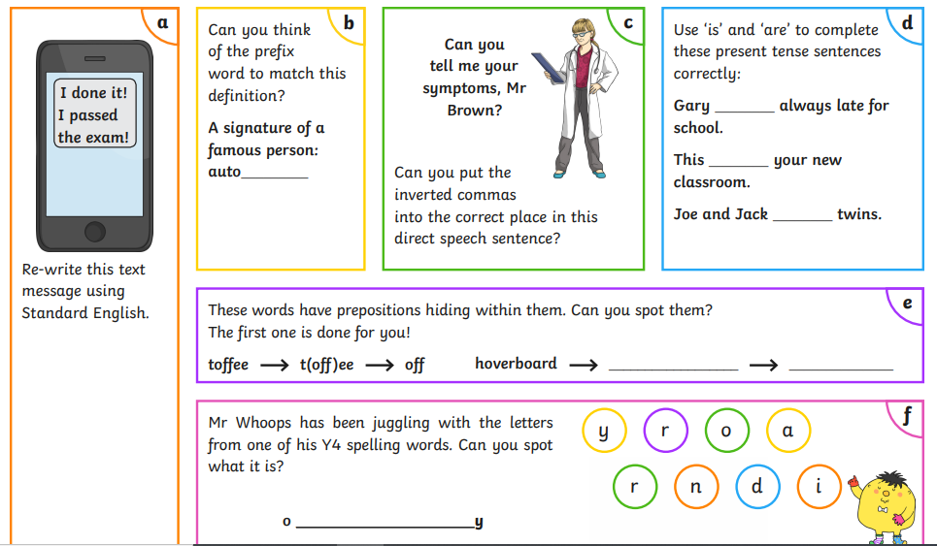
Friday 14th January Year 5 Homework SPAG

