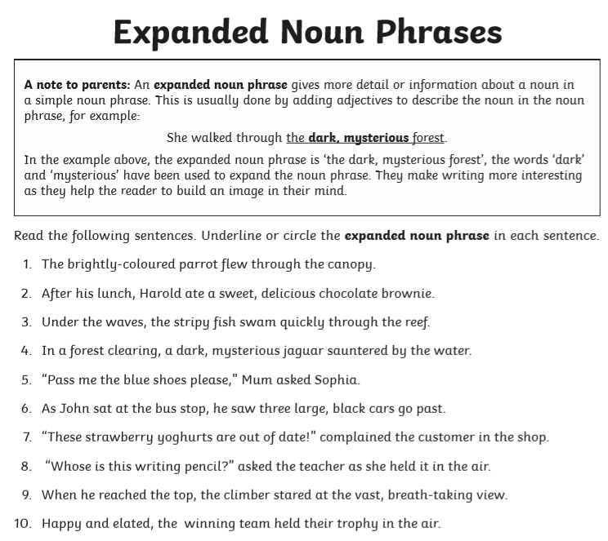
Extra Challenge (optional)
Can you create your own sentences which contain expanded noun phrases? Write them on the back of this piece of paper or use your own if you prefer.
To be successful:
- Don’t forget to separate the adjectives with a comma.
- Remember capital letters and full stops.
- Handwriting should be clear, joined (make sure you form letters correctly).

