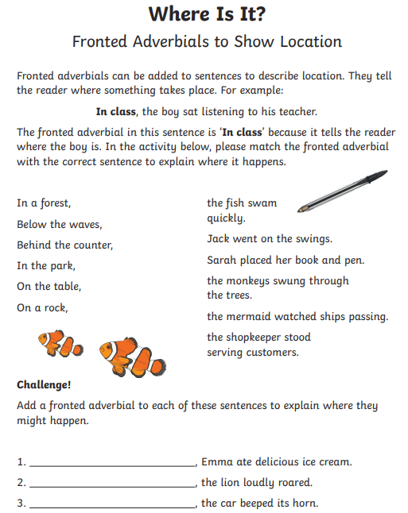
Extra Challenge (optional)
Can you create your own sentences which begin with a fronted adverbial to show where? Write them on the back of this piece of paper or use your own if you prefer.
To be successful:
- Don’t forget to place a comma after the fronted adverbial (this could be a single word or a phrase).
- Remember capital letters and full stops.
- Handwriting should be clear, joined (make sure you form letters correctly).

