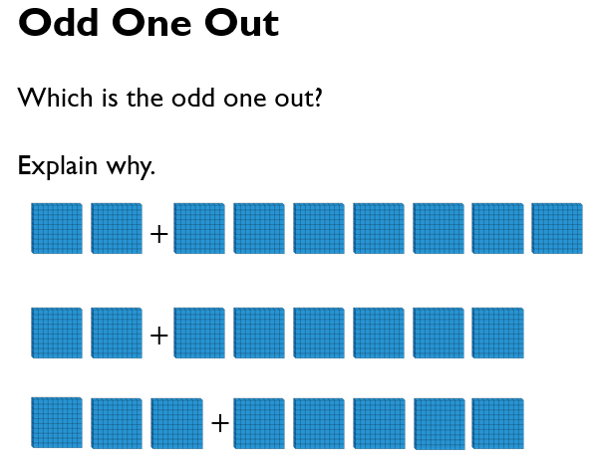

TIP: Remember, when   
crossing 100, use ten 10’s to make 100.

