This week we have been learning to cross10 and cross 100. Use the number lines to help you with these calculations.

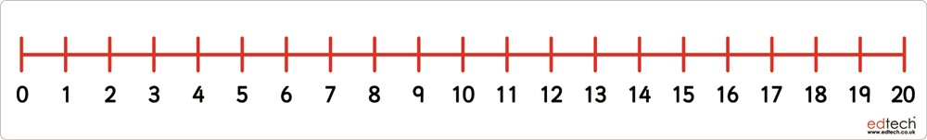

Use lines and dots to represent the biggest number, and cross out the right amount of tens to find the answer.

