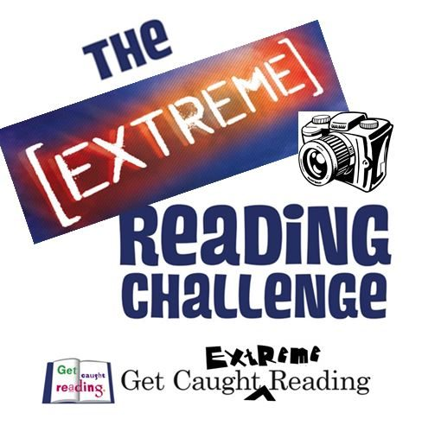
Take a photo of yourself reading in an ‘extreme’ place (without endangering yourself)! Be as creative or imaginative as you like. We look forward to receiving your photos, which will be displayed in school at the start of term. Entries welcome from pupils, parents and staff. Email your photos to Lsmerdon@wadebridgeprimary.co.uk Remember to state your name, class, the title of the book you are reading and your location. Competition opens on Saturday 23rd October and closes on Sunday 31st October. There will be a prize per year group and an overall prize for the most extreme! Good Luck!

