English Homework 21.1.22
Useful Homophones
This week’s homework is a recap – we have taught this in school but we still find lots of you making errors in your writing and choosing the wrong homophone.

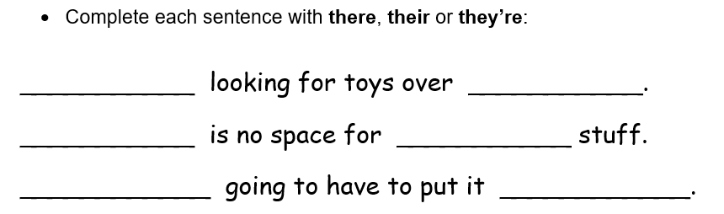
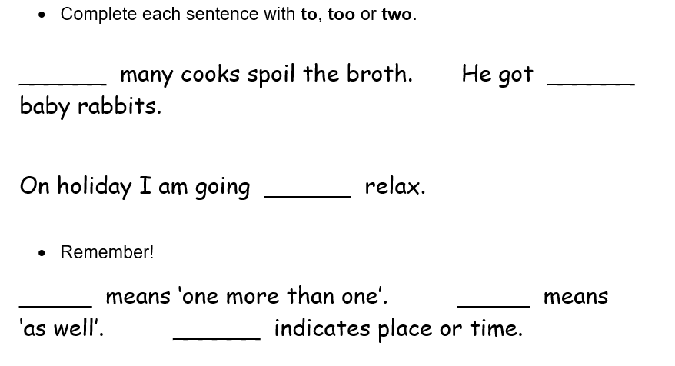

Turn over to find some more!

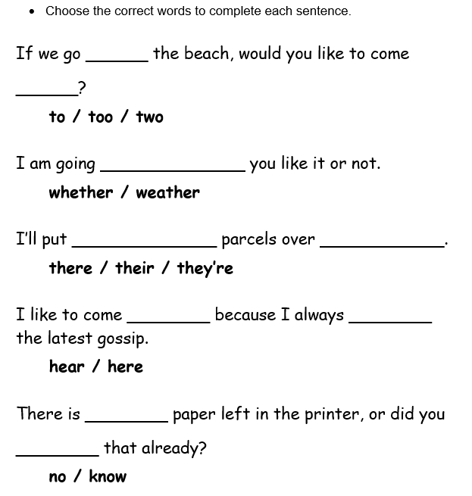
CHALLENGE:
Can you write a ‘Silly Story’ using as many of these important homophones as you can? The story can be as daft as you like, but the homophones spellings must make sense in the context of the sentence

