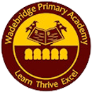
Optional Home Learning Grid
Year Group: One Topic: What’s at the bottom of the garden? Term: Spring Two
Throughout the term, please choose from these learning tasks below. As we will be only exploring this topic for the second part of Spring term, we have shortened the list of tasks. Learning can be recorded in many ways so please be creative! You may choose to record your learning by taking photographs or videos and emailing them to your teacher.
Science and Geography:  We are surrounded by natural beauty in Cornwall but what can we do to keep it safe? Follow this link and choose a challenge… https://www.rspb.org.uk/get-involved/activities/nature-on-your-doorstep/ | Science:  With an adult, explore your garden or a local park/forest. What plants can you see? Can you name the trees? How do you think the trees change through the seasons? With the help from an adult choose (a safe!) plant to dissect and label.  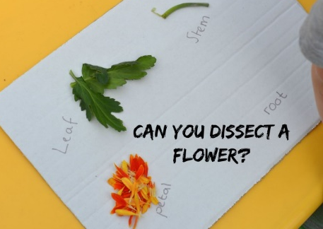
Art  Using your collage skills, can you create a garden picture?  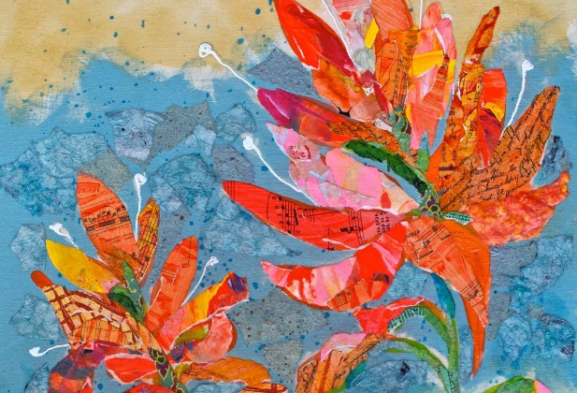 | Art:  Can you find out about a famous artist called Andy Goldsworthy? What do you notice about his Art? Can you create a picture in the style of his work using natural materials? Send us a picture!  